Kubernetes Task

Step 1:

Setting Up the Minikube in Local Machine using those commands

Invoke-WebRequest -Uri "https://dl.k8s.io/release/v1.30.1/bin/windows/amd64/kubectl.exe" -OutFile "kubectl.exe"

And Need to enable the features for hyperv

Enable-WindowsOptionalFeature -Online -FeatureName Microsoft-Hyper-V-Tools-All –All

And then Perform the Restart:

Step2:

We can also check the Hyperv enabled using this command

Enable-WindowsOptionalFeature -Online -FeatureName Microsoft-Hyper-V-All -All

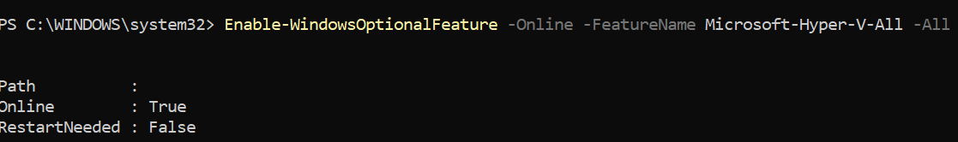

It is in Running State

Step3:

Start the Hyperv with Minikube with this command

minikube start --driver=hyperv

And it is Done:

Screenshot mentioned Below

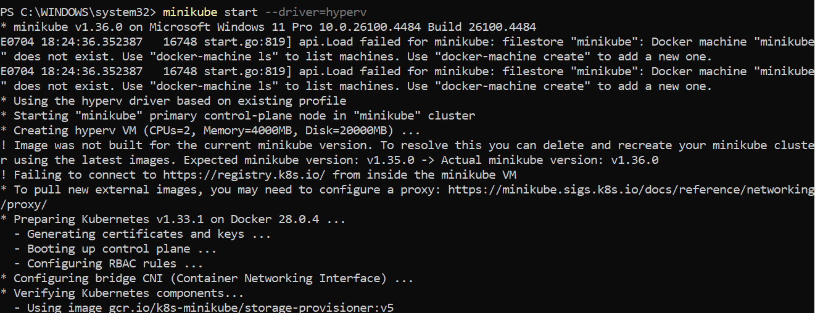

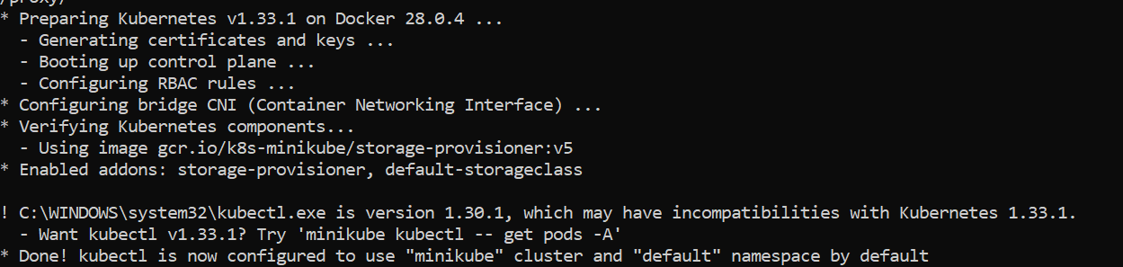

So Minikube is Running Using get node

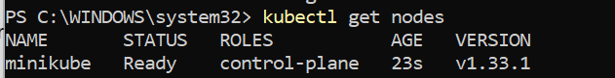

Step4:

Get the Namespaces

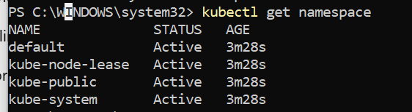

And I created one new namespace into that

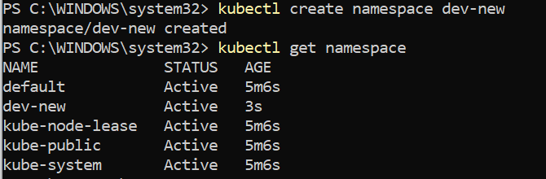

Step 4:

And creating the nginx in to that

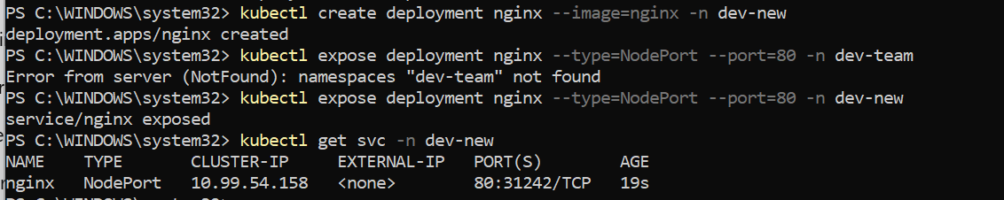

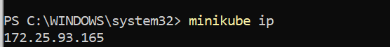

And Using the Minikube Ip 172.25.93.165 and then the Exposed as 31242on the Minikube VM

So if we hit the Ip like <http://172.25.93.165:31242/> we will get the nginx page

